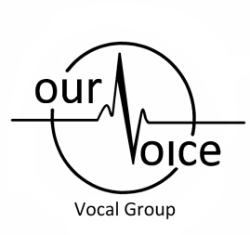 | Shanna’s House of Music  &  Our Voice-Vocal Group  Registration  Piano, Vocal, and Choir  2016-2017

Cell :780-708-3763 Email: shannawmusic@gmail.com Website: shannawmusic.weebly.com

Studio Policy:
- Post dated cheques are Required dated September through May for the 1st of each month. There will be a $5 a day late fee if payment is not made on time.
- Arrive at lesson approximately five minutes early (no sooner please)
- Please be on time to pick up your child after their lesson
- If, for any reason, you cannot finish the year, I will retain a one month’s payment and return the remaining cheques to you.
- Loaned books/CD’s for copying purposes need to be returned by the next lesson.

Registration Fee: (payable at first lesson & is non refundable)
- Piano or Voice - $25.00
- Choir - $25.00
- Both (Choir & Piano or Voice) $35.00

T-shirt Size: (for choir members only)
Youth Small | Youth Medium | Adult Small | Adult Medium |  | Adult Large |  | Adult X-Large
**please take into account if your child is still growing**

Registration Information:
Student’s Name: |  |  | _______________________________________________ |  |  |  |  |  |  |  |  |  |  | D.O.B |  | ___________________
Parent(s) Name: |  |  | ________________________________ |  |  |  |  |  |  |  | E-mail Address: |  |  |  | __________________________
Mailing Address: |  |  | _____________________________________________________________________________
Home Phone Number: |  |  |  | ____________________________ |  |  |  |  |  |  | Cell Phone #: |  | ____________________________
Emergency Contact Information:
Name: | _______________________ |  |  |  |  |  | Phone #: |  | _______________ |  |  | Relationship: |  |  |  | ___________________
Name: | _______________________ |  |  |  |  |  | Phone #: |  | _______________ |  |  | Relationship: |  |  |  | ___________________
Please check the box that is applicable: (choir members only)
Age Group: |  | 8-12 |  |  |  |  |  | 13-17 |  |  |  |  |  | 18+

Lesson Fee Schedule: (please check on-line for dates of closure)
Piano lessons $25.00/ 30 min lesson
Voice lessons $35.00/ 30 min lesson
Choir $10 per week per person

